**Student ID: Cse24-073**

**Student Name: Lorato Moilwa**

**Student Email:** [**Cse24-073@thuto.bac.ac.bw**](mailto:Cse24-073@thuto.bac.ac.bw)

**Assignment Title: OOAD with Java 2025**

**Programme of Study: BSc (hons) Computer Systems Engineering**

**Year Of Study: 2025 Year 2 semester 1**

**BANKING SYSTEM**

**PART A: SYSTEM DOCUMENTATION**

1. **REQUIREMENTS ELICITATION (MOCK INTERVIEW**

**Interview Record: Appendix**

**Date and time:** 17-09-2025, 19:35

**Place of the interview:** Teams online meeting

**Interviewer:** Lorato Moilwa (System Analyst)

**Interviewee:** Mr Themba Moeng (Tutor)

Here is the interaction from the interview I held for the bits of the functional requirements.

1. **Lorato Moilwa:** Can you tell me what the system should do for the customers?

**Themba Moeng:** So primarily the system should provide the services to facilitate the operations such as withdrawing, depositing, viewing the balances and also have the ability to see the transaction history list. The customers should be able to login and logout as well as do the operations listed here.

1. **Lorato Moilwa:** Are there any rules for opening accounts?

**Themba Moeng:** Yes, there are rules as stated in the assignment document. The investment account requires an initial deposit of BWP 500.00. The cheque account can only be opened if the customer is employed and must include employer information. The other rule is that the savings account exists for storing funds and accrues a small interest and the account does not allow any withdrawals from it.

1. **Lorato Moilwa:** Are there interest rates and how often are they charged?

**Themba Moeng:** There are interest rates yeah, the investment account charges 5% monthly, savings account charges 0.05% monthly so this interest must be applied to the account balance monthly.

1. **Lorato Moilwa:** Would you say there are any constraints on accounts and ownership?

**Themba Moeng:** Of course, we say a customer can hold multiple accounts. An account cannot exist without a customer. Transactions should be recorded with timestamps and types such as deposit, withdraw or interest payment.

1. **Lorato Moilwa:** Last question, are we expecting any non-functional requirements?

**Themba Moeng:** Yes, we expect the system to be secure and that can be done by inputting username and passwords when we are storing data, the data should be incorporated meaning if you are looking for the database tables you should see encrypted data.And only if you have logged on the system should you see the data.

* 1. **FUNCTIONAL REQUIREMENTS. (What the system do)**

**\*** Primarily it is used to provide the services to facilitate the operations such as withdrawing, depositing, viewing the balance and also the ability to see the transaction list of the associated account in terms of putting a starting and ending date.

**\***The customer should be able to login in order to access their accounts.

*The system should be able to allow customers to open more than one account which can either be savings, investment and cheque account.

*The system should also enforce that the minimum initial deposit for an investment account is P500.

*One more thing the system should do is to calculate and apply monthly interest which is 5% for investment accounts and 0.05% for the savings accounts.

**1.2. NON-FUNCTIONAL REQUIREMENTS. (How the system should behave.)**

**\*Security**: There must be an encryption for all the customer’s authentication and sensitive operations. For example using hashed passwords for the most personal things.

**\*Performance**: The performance for account balance queries whether its deposit or withdraw transactions should be able to respond within 1-2 seconds under normal loads.

**\*Reliability**: This banking system should be able to support everyday operations in order to backup and recover data.

**\*Usability**: The customer UI should be in clear simple form with readable account lists for deposit and withdraw buttons as well as the transaction history.

**\*Maintainability**: The banking system codebase should allow medication and extension hence it should follow solid principles and be modular.

1. **STRUCTURAL UML MODELLING**
   1. **System Use Case Diagram**

-ACTORS: Customer, Bank Stuff, System Scheduler

-USE CASES: Register customer

Login

Open Account

Deposit Funds

Withdraw Funds

View Balances and view transaction history

Apply monthly interest/ calculate

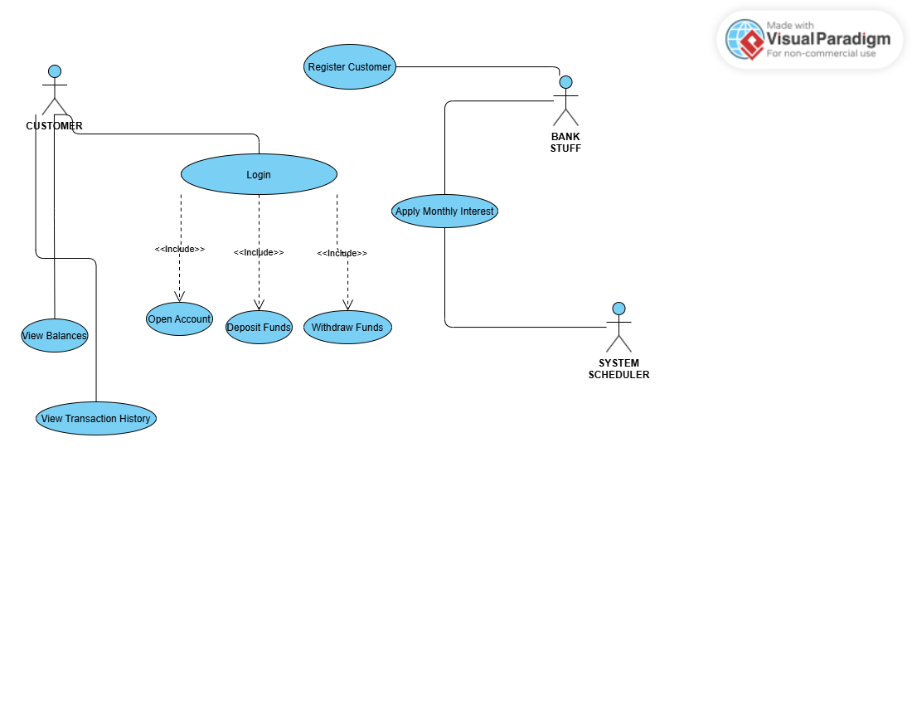

**2.2. Class Diagram**

This shows the static structure of the banking system.

-We have two entities which is a customer and account. A customer can have many accounts. An account can be owned by one customer and the account can record many transactions.

-Savings, investment and cheque accounts all inherit account. (Inheritance).

-Savings account and investment account implement interest Bearing (Interface).

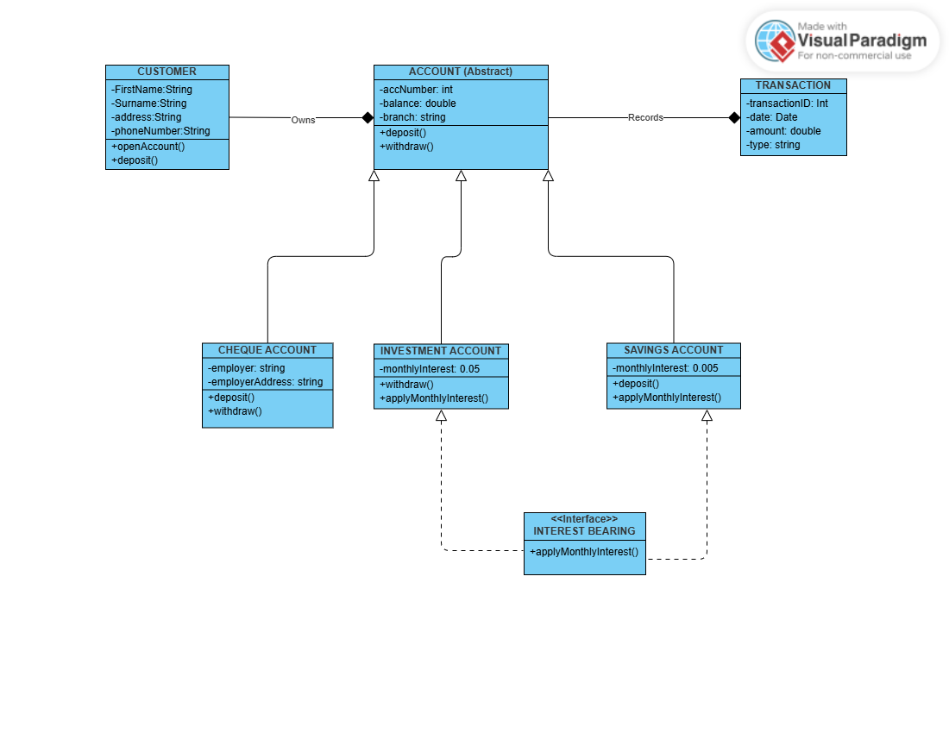

1. **BEHAVIOURAL UML MODELLING**
   1. **Sequence Diagram**

**\*LOGIN FUNDS**

**-**The customer submits the login credentials to the authentication service.

**-**The auth service will validate by checking for customer username in the customer repository.

**-**The customer repository will reply back to the auth service with the customer records. The Session manager will reply with a successful session to the auth service. The auth service then returns success or invalid credentials to the customer UI.

Session Manager*

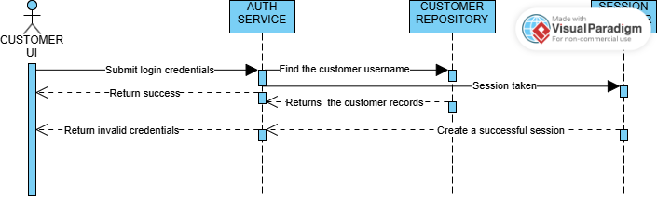

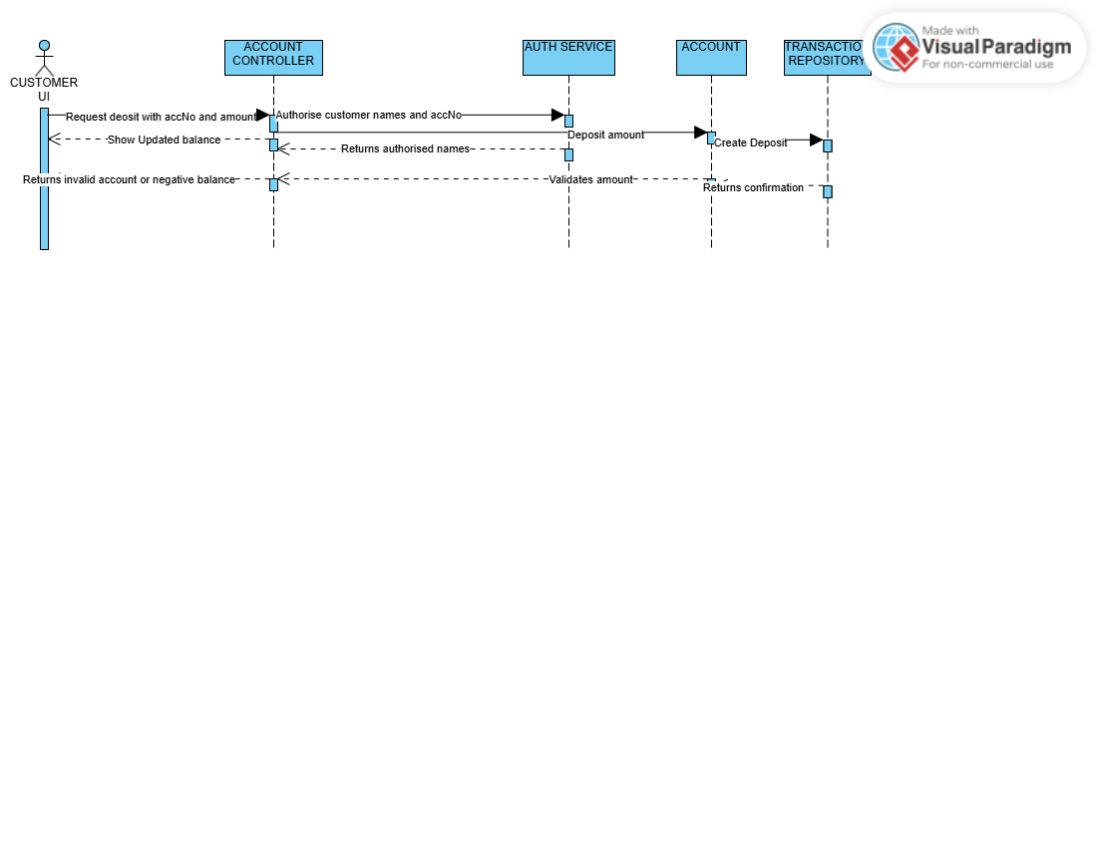

\***DEPOSIT FUNDS**

We got the customer UI, Account Controller, Account, auth service then the transaction Repository in the above diagram.

* 1. **State diagram**

Using Pay Interest as a key class in Investment Account.

-In the initial stage the customer requests to open an account with atleast 500 pula.

-It reaches the create stage and the account is activated and ready to be used.

-Once it is active deposits and withdrawals can be made to keep it active and applies and calculates monthly interests of 5%.

-Once it is on a dormant stage it means the account has not had any activity in a long time hence it can be deactivated. It accrues interest monthly though.

-The customer the goes ahead and reactivates the account.

-From the dormant stage the account can be officially closed because it is not in use. And only if it inactive.

